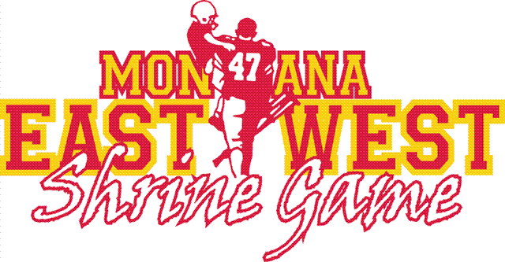
Dear 2020 Players & Cheerleaders:
As the President of the Montana East-West Shrine Game, I would like to take the time to personally invite you to attend the 2021 Montana Shrine Game. This will be our opportunity to further acknowledge your selection for the 2020 game that was canceled as a result of the Covid-19 Pandemic.
This year’s game will be held on Saturday June 19th at Daylis Stadium in Billings, with the Banquet on Friday June 18th at the Billings Hotel and Convention Center, which is the host hotel for the event. We will also have a Parade on Saturday June 19th which will include a trailer for all players and cheerleaders to ride on as part of the parade festivity.
As a 2020 Player and Cheerleader, you are invited to attend all scheduled events. You will receive a free dinner at the banquet and free entry into the football game. Your parents and family members who would like to attend are responsible for the cost of admission to both the dinner and the game. Please plan on wearing your 2020 Game Jersey or the Cheerleader Shirt that you received for the 2020 game. The 2020 Players and Cheerleaders will be announced at the Banquet and at the football game as a team. We will also have a special designated spot for you to sit at the football game.
A registration form can be found on our web site (MTShrineGame.org). Please take the time to complete this form if you plan on attending the events and include the number of people in your group that will attend. This is needed to ensure we have an accurate head count for the Banquet Dinner.
Congratulations again on your 2020 selection and we look forward to the opportunity to see you during this year’s event.
Sincerely,

Fred Thompson
President, Montana East-West Shrine Game

